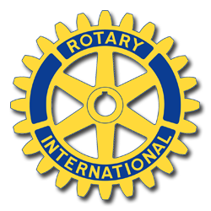
LEDYARD ROTARY
CLASSIC CAR CRUISE
LEDYARD FAIRGROUNDS
Route 117

A COMMUNITY BENEFIT EVENT

Saturday July 25, 2015 10:00AM

All Classic Cars, Pre and Post WWII Vehicles, Trucks,
Military, Special Interest Vehicles Welcome
You Picked A Great Day to Cruise With Us!
For our Drawing we have the best prizes so far this year!

Concessions Food & Beverages

*Free Admission *50/50 Raffle Drawing
* Live Music DJ * Tea Cup Raffle Prizes
* Free Parking for Spectators * Great Food
* Covered Pavilion with Seating
Fabulous Prizes! Go Check Out the Prize Table!

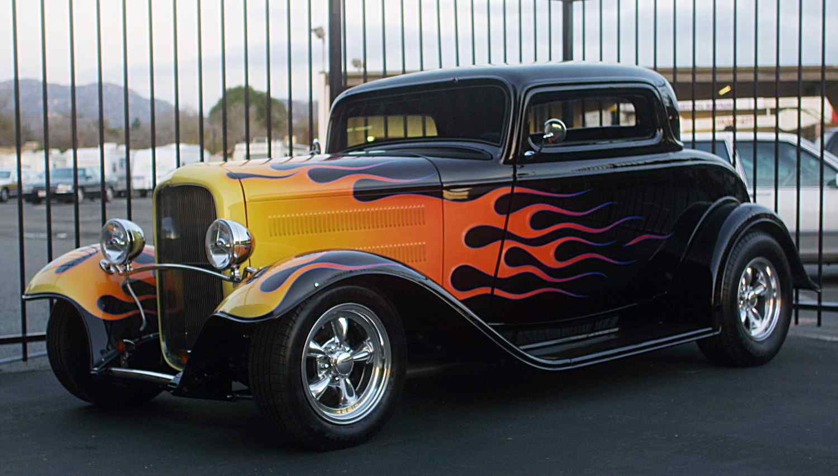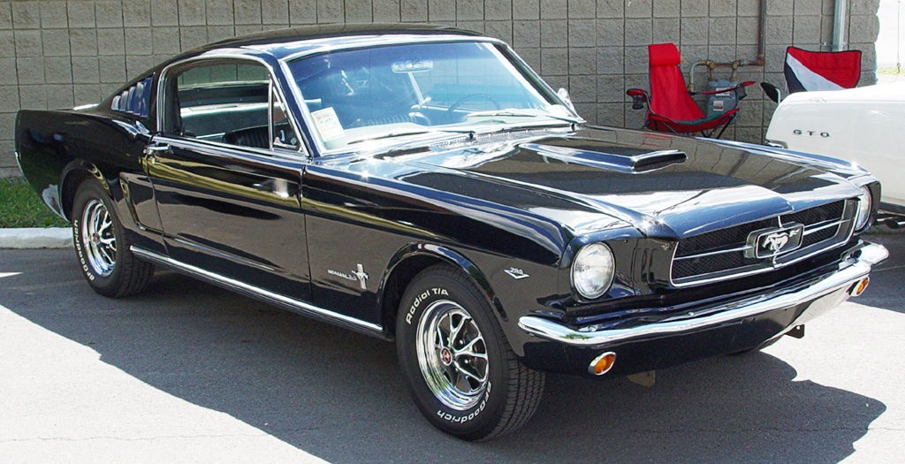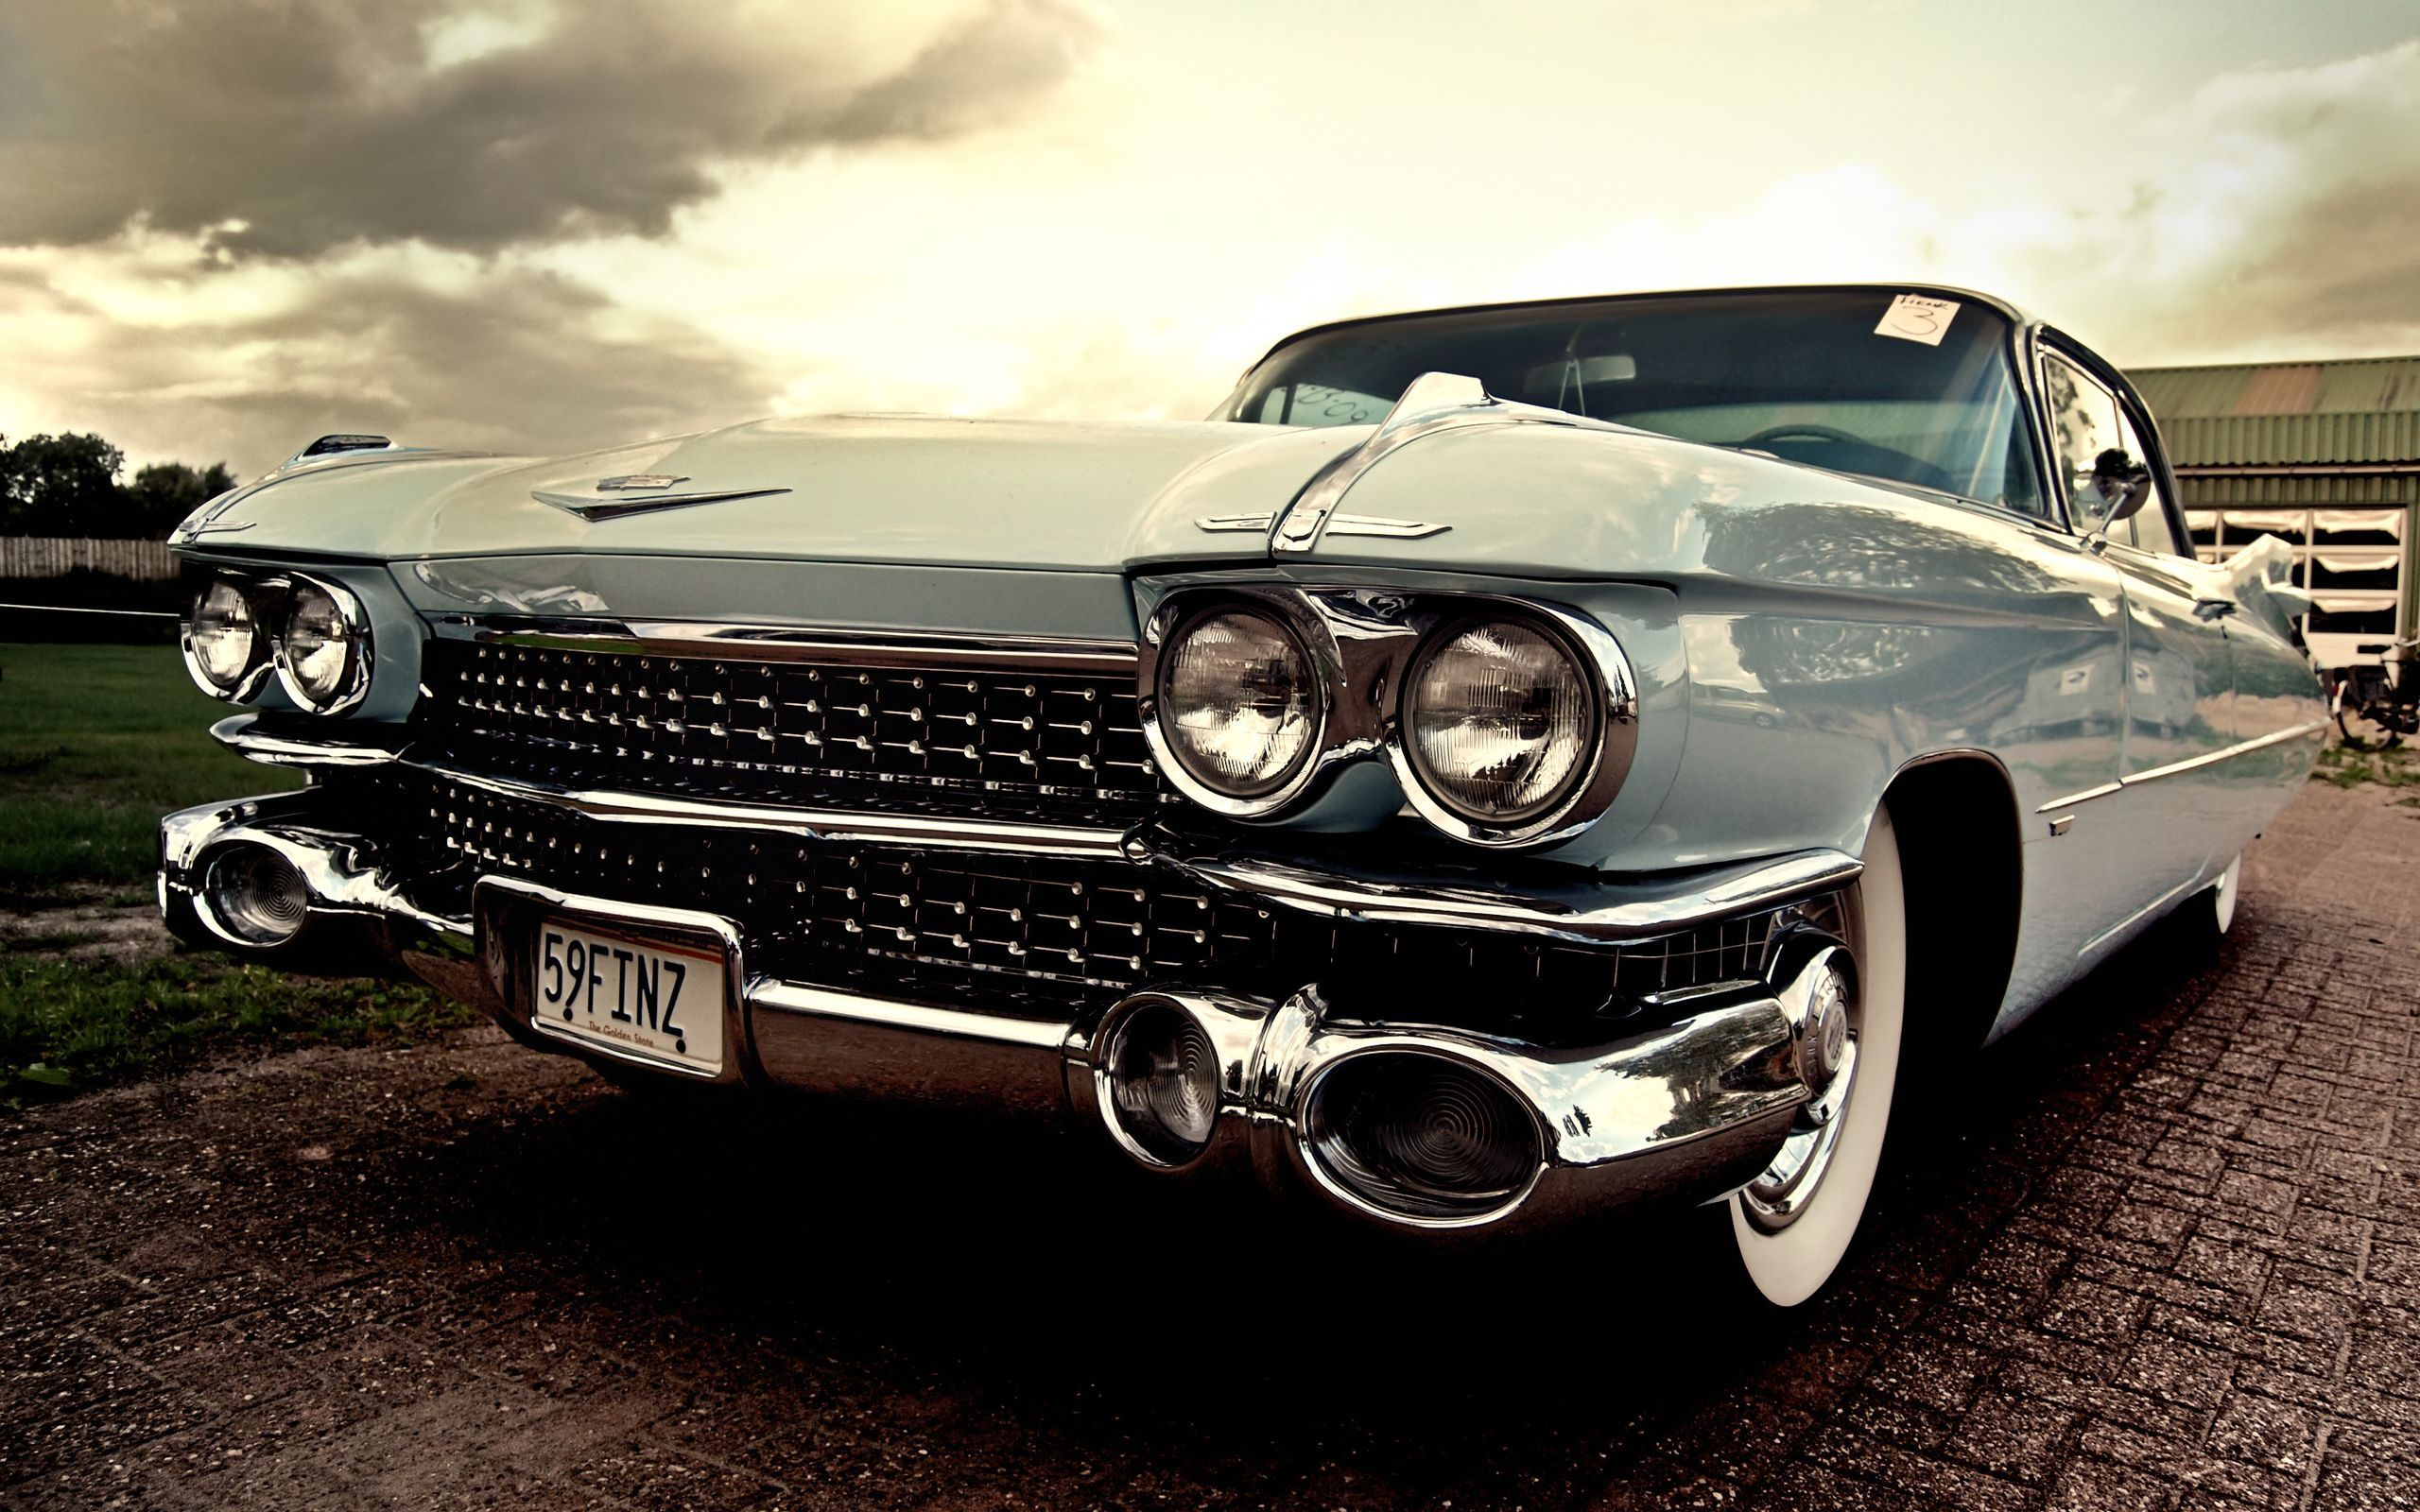

All Proceeds are donated to Ledyard Rotary Scholarship Fund
In the event of a Rain-Out on 7/25 , this Cruise will be held Saturday 8/1
For more information go to http://www.ledyardrotary.org/or call 860-460-2287
Don't Miss this Fun Community Event!
DATES SUBJECT TO CHANGE. Check http://www.ledyardrotary.org for Up to Date Information
Limited Space- Entrance closed when lot is full!

